
What is it?
Cogmed Working Memory Training
- Computerised adaptive working memory training programme
- Developed by Dr Torkel Klingberg
- 3 versions: preschool, school-age & adult
- 25 sessions, each 30-45 minutes
- Bought by Pearson in 2010 & now marketed worldwide
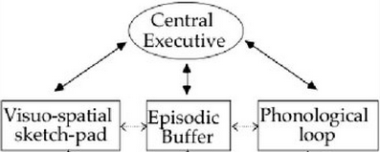
Based on 3 main theories:
- Model of WM – including Visuo-spatial and phonological components
- Link between WM & learning
- Flexibility of WM capacity

What does the research suggest?

- Consensus that Cogmed is likely to be an effective short-term intervention for WM on tasks very similar to those trained
- Lack of good evidence for long term maintenance of effects and for far transfer

Generalisable?
- Gropper, Gotlieb, Kronitz & Tannock (2014) found significantly greater improvements on WM measures & lower rates of ADHD symptoms and cognitive failures

But, this study used waiting list controls who received no researcher attention and self-report measures of behaviour.

- Chacko et al (2013) found that participants (in the Cogmed training active group) demonstrated greater gains on WM tasks (compared to training placebo group) but NO DIFFERENCES in parental & teacher ratings of attention, impulsivity & academic achievement
- Melby-Lurvag and Hulme (2013) conducted a meta-analyses and concluded that there was no evidence that ‘training produces generalised gains to the other skills that have been investigated (verbal ability, word decoding, or arithmetic),’

Maintained over time?

- Holmes, Gathercole & Dunning (2009) found significant gains in WM scores (greater for adaptive training ps compared to those trained on a non-adaptive version of Cogmed) which remained significant at 6 months. Also, significant gains in mathematical reasoning after 6 months,

But this study found no significant improvements (measured at 6 months stage) in all other far transfer measures.

- Melby-Lurvag and Hulme (2013) concluded that ‘participants’ scores on all of these sorts of measures, including attentional control, arithmetic, and word decoding tests, were not significantly improved compared to the control groups after a delay’

